Location-Based Spatial Query Processing
in Wireless Broadcast Environments

Thesis / Dissertation submitted in partial fulfillment of the requirement for the award of the degree of B.Tech.

BY

K.SRIVIDYA
08VV1A0505
P. SHIREESHA | 08VV1A0501
G.AMRUTHARAJU | 08VV1A0537

B.SRIHARI 08VV1A0528

Under the esteemed guidance of
O. Srinivasa Rao
Assistant Professor
Head of Department
Department of Computer Science and Engineering
University College of Engineering
JNTUK – Vizianagaram Campus



Department of Computer Science and Engineering
University College of Engineering
JNTUK – Vizianagaram Campus
VIZIANAGARAM – 535 003, A.P., INDIA
(2008-2012)

CERTIFICATE

This is to certify that the thesis / dissertation entitled “Location-Based Spatial Query Processing in Wireless Broadcast Environments” that is
being submitted by K.SriVidya (08VV1A0505), P.Shireesha (08VV1A0501), G.AmruthaRaju(08VV1A0537),K.Srihari(08VV1A0528) in partial fulfillment for the award of B.Tech in Computer Science and Engineering to the Jawaharlal Nehru Technological University Kakinada is a record of bonafide work carried out by them under our guidance and supervision.

The results embodied in this thesis have not been submitted to any other University or Institute for the award of any degree or diploma.

Signature of Supervisor/Guide Head of the Department
Name and Designation

O. Srinivasa Rao
Assistant Professor
Department of Computer Science & Engineering
University College of Engineering
JNTUK – Vizianagaram
Campus
Andhra Pradesh.

ACKNOWLEDGEMENT

As a note of acknowledgement, with great solemnity and sincerity, we offer our profuse thanks to O. Srinivasa Rao, Head of the Department, Department of Computer Science and Engineering, for guiding us all through our project work, giving a right direction and shape to our learning by extending his expertise and experience in the field of technical education.

We also thank Dr. G.Rangajanardhan, Principal, for extending his utmost support and cooperation in providing all the provisions for the successful completion of the project.

We sincerely thank all the members of the staff in the Department of Computer Science and Engineering for their sustained help in our pursuits.

We thank all those who contributed directly or indirectly in successfully carrying out this work.

K.SRIVIDYA 08VV1A0505
P. SHIREESHA 08VV1A0501
G.AMRUTHARAJU 08VV1A0537
B.SRIHARI 08VV1A0528

ABSTRACT

Location-based spatial queries (LBSQ s) refer to spatial queries whose answers rely on the location of the inquirer. Efficient processing of LBSQ s is of critical importance with the ever-increasing deployment and use of mobile technologies. We show that LBSQ s has certain unique characteristics that the traditional spatial query processing in centralized databases does not address. For example, a significant challenge is presented by wireless broadcasting environments, which have excellent scalability but often exhibit high-latency database access. In this paper, we present a novel query processing technique that, though maintaining high scalability and accuracy, manages to reduce the latency considerably in answering LBSQ s. Our approach is based on peer-to-peer sharing, which enables us to process queries without delay at a mobile host by using query results cached in its neighboring mobile peers. We demonstrate the feasibility of our approach through a probabilistic analysis, and we illustrate the appeal of our technique through extensive simulation results.
In this project we present a survey on the work that has been done in the area of intrusion detection in mobile ad hoc networks.

TABLE OF CONTENTS
1. INTRODUCTION
1.1 INTRODUCTION TO THE PROJECT……………………………..…………8
1.2 PURPOSE………………………………………………………………..……………….8

2. LITERATURE SURVEY
2.1 OVERVIEW OF THE PROJECT………………………………………………..9
2.2 LANGUAGE SPECIFICATION…………………………………………………..9
2.3 CURRENT SYSTEM……………………………………………………………….16
2.4 PROPOSED SYSTEM……………………………………………………………..16
2.4.1 PROJECT SCOPE………………………………………………………….10
2.4.2 PROJECT OVERVIEW…………………………………….…………….10

3. ANALYSIS
3.1 FEASIBILITY STUDY………………………………………………………………16
3.1.1 TECHNICAL FEASIBILITY………………………………………………16
3.1.2 ECONOMICAL FEASIBILITY ..……………………………………….16

3.2 REQUIREMETS
3.2.2 HARDWARE REQUIREMENTS ……..……………………………….17
3.2.3 SOFTWARE REQUIREMENTS …………………………………..……17

3.3 MODULES
3.3.1 Multiple peer simulation Module……………………………………18
3.3.2 Server Module…………………………………………………………………18
3.3.3 Sharing-based nearest neighbor query…………………………18
3.3.4 In module given input and expected output………………….19

4. DESIGN
4.1 ACTORS………………………………………..……..…………………………………….21
4.2 USER…………………………………………..…..……………………….................21
4.3 USE CASES………………………………….………………………………………………21
4.6 CLASS DIAGRAM…………………………………………………………………………..22
4.7 DATA FLOW DIAGRAM…………………………………………………………………23

5. IMPLEMENTATION
  - IMPLEMENATION OF THE PROJECT…………………..…………………. 24
    - Centralized Server Screen……………………………………… …………25
5.1.2Mobile Host1 Screen……………………………………………………….27
5.1.3Mobile Host2 Screen……………………………………………………….27
    - Mobile Host3 Screen……………………………………………………..28

6.CODING...................................................................................28
7. TESTING……………………………………………………………………………….. … ……. 75
7.1 TESTING CONCEPTS……………………………………………………………………75
7.2 TESTING ACTIVITIES …………………………………………………………………76

7.3 TESTING APPROACHES……………………………………………………………………79
7.3.1 WHITE BOX TESTING……………………………………………………….79
7.3.2 BLACK BOX TESTING……………………………………………………….79

8. CONCLUSION………………………………………………………………………………….80

9. REFERENCES………………………………………………………………………………….80

1. INTRODUCTION

1.1 INTRODUCTION TO PROJECT
Location-based spatial queries (LBSQ s) refer to spatial queries whose answers rely on the location of the inquirer. Efficient processing of LBSQ s is of critical importance with the ever-increasing deployment and use of mobile technologies. We show that LBSQ s has certain unique characteristics that the traditional spatial query processing in centralized databases does not address. For example, a significant challenge is presented by wireless broadcasting environments, which have excellent scalability but often exhibit high-latency database access. In this paper, we present a novel query processing technique that, though maintaining high scalability and accuracy, manages to reduce the latency considerably in answering LBSQ s. We demonstrate the feasibility of our approach through a probabilistic analysis, and we illustrate the appeal of our technique through extensive simulation results.
1.2 PURPOSE
This Software Requirements Specifications (SRS) specifies the requirements of the Discriminative Learning and Recognition of Image Sets Using Canonical Correlations. We address the problem of comparing sets of images for object recognition, where the sets may represent variations in an object’s appearance due to changing camera pose and lighting conditions. Canonical Correlations (also known as principal or canonical angles), which can be thought of as the angles between two dimensional subspaces, have recently attracted attention for image set matching. Canonical correlations
offer many benefits in accuracy, efficiency, and robustness compared to the two main classical methods: parametric distribution-based and nonparametric sample-based matching of sets.

2. LITERATURE SURVEY

2.1 OVERVIEW OF THE PROJECT
This project is to reduce the latency considerably in answering LBSQs. Our approach is based on peer-to-peer sharing, which enables us to process queries without delay at a mobile host by using query results cached in its neighboring mobile peers

2.2 LANGUAGE SPECIFICATION
2.2.1 Java Swings:
Swing is the primary Java GUI widget toolkit. It is part of Sun Microsystems' Java Foundation Classes (JFC) — an API for providing a graphical user interface (GUI) for Java programs.
Swing was developed to provide a more sophisticated set of GUI components than the earlier Abstract Window Toolkit. Swing provides a native look and feel that emulates the look and feel of several platforms, and also supports a pluggable look and feel that allows applications to have a look and feel unrelated to the underlying platform.

2.2.2 Advantages:

Swing is platform independent both in terms of expression (Java) and implementation (Look-and-Feel).

Extensible:
Swing is a highly partitioned architecture, which allows for the "plugging" of various custom implementations of specified framework interfaces: Users can provide their own custom implementation(s) of these components to override the default implementations. In general, Swing users can extend the framework by extending existing (framework) classes and/or providing alternative implementations of core components.
Swing is a component-based framework. The distinction and components is a fairly subtle point: concisely, a component is a well-behaved object with a known/specified characteristic pattern of behavior. Swing objects asynchronously fire events, have "bound" properties, and respond to a well-known set of commands (specific to the component). Specifically, Swing components are Java Beans components, compliant with the Java Beans Component Architecture specifications.
Customizable:
Given the programmatic rendering model of the Swing framework, fine control over the details of rendering of a component is possible in Swing. As a general pattern, the visual representation of a Swing component is a composition of a standard set of elements, such as a "border", "inset", decorations, etc. Typically, users will programmatically customize a standard Swing component (such as a JTable) by assigning specific Borders, Colors, Backgrounds, opacities, etc., as the properties of that component. The core component will then use these properties (settings) to determine the appropriate renderers to use in painting its various aspects. However, it is also completely possible to create unique GUI controls with highly customized visual representation.

Configurable:
Swing's heavy reliance on runtime mechanisms and indirect composition patterns allows it to respond at runtime to fundamental changes in its settings. For example, a Swing-based application can change its look and feel at runtime. Further, users can provide their own look and feel implementation, which allows for uniform changes in the look and feel of existing Swing applications without any programmatic change to the application code.
Lightweight UI:
Swing's configurability is a result of a choice not to use the native host OS's GUI controls for displaying itself. Swing "paints" its controls programmatically through the use of Java 2D APIs, rather than calling into a native user interface toolkit. Thus, a Swing component does not have a corresponding native OS GUI component, and is free to render itself in any way that is possible with the underlying graphics APIs.
However, at its core every Swing component relies on an AWT container, since (Swing's) JComponent extends (AWT's) Container. This allows Swing to plug into the host OS's GUI management framework, including the crucial device/screen mappings and user interactions, such as key presses or mouse movements. Swing simply "transposes" its own (OS agnostic) semantics over the underlying (OS specific) components. So, for example, every Swing component paints its rendition on the graphic device in response to a call to component.paint(), which is defined in (AWT) Container. But unlike AWT components, which delegated the painting to their OS-native "heavyweight" widget, Swing components are responsible for their own rendering.
This transposition and decoupling is not merely visual, and extends to Swing's management and application of its own OS-independent semantics for events fired within its component containment hierarchies. Generally speaking, the Swing Architecture delegates the task of mapping the various flavors of OS GUI semantics onto a simple, but generalized, pattern to the AWT container. Building on that generalized platform, it establishes its own rich and complex GUI semantics in the form of the JComponent model.
2.2.3 Why jdk 1.6.0?
- Native platform Security (GSS/Kerberos) integration.
- Java Authentication and Authorization Service (JAAS) login module that employs LDAP authentication.
- New Smart Card I/O API.
- New Security Request Framework enables requesting of certificates over a number of protocols.
JDK 5.0 main features include Generics, Autoboxing, Annotations, static imports and Enums. JDK 1.6 features include all JDK 5.0 features.
Javax.crypto.cipher:
Public class Cipher
Extends Object
This class provides the functionality of a cryptographic cipher for encryption and decryption. It forms the core of the Java Cryptographic Extension (JCE) framework.
In order to create a Cipher object, the application calls the Cipher's getInstance method, and passes the name of the requested transformation to it. Optionally, the name of a provider may be specified.
A transformation is a string that describes the operation (or set of operations) to be performed on the given input, to produce some output. A transformation always includes the name of a cryptographic algorithm (e.g., DES), and may be followed by a feedback mode and padding scheme
Changes in I/O :
This is a new feature added in Java SE 6, which has the ability to read text from a terminal without having it echo on the screen through java.io.Console.

Leveraging Security in the Native Platform Using Java SE 6 Technology:
The JAVA SE 6 provides a large set of security APIs. These Security APIs span a wide range of areas, including cryptography public key infrastructure, secure communication, authentication, and access control.
Java security:
Before moving on to a discussion of Java security, one should have an understanding of the potential problems raised by executable content. The advantages of executable content come from the increase in power and flexibility provided by software programs. The increased power of Java applets (the Java term for executable content) is also the potential problem. When a user is ``surfing'' the Web, they should not have to worry that an applet may be deleting their files or sending their private information over the network surreptitiously.
The essence of the problem is that running programs on a computer typically gives that program access to certain resources on the host machine. In the case of executable content, the program that is running is untrusted. If a Web browser that downloads and runs Java code is not careful to restrict the access that the untrusted program has, it can provide a malicious program with the same ability to do mischief as a hacker who had gained access to the host machine. Unfortunately, the solution is not as simple as completely restricting a downloaded programs access to resources. The reason that one gives programs access to resources in the first place is that in order to be useful a program needs to access certain resources. For example a text editor that cannot save files is useless. Thus, if one desires to have useful and secure executable content, access to resources need to be carefully controlled.
2.3 Existing System

  - Existing techniques cannot be used effectively in a wireless broadcast environment, where only sequential data access is supported.
  - It may not scale to very large user populations.
  - In an existing system to communicate with the server, a client must most likely use a fee-based cellular-type network to achieve a reasonable operating range.
  - Third, users must reveal their current location and send it to the server, which may be undesirable for privacy reasons

2.4 Proposed System

- This System is a novel approach for reducing the spatial query access latency by leveraging results from nearby peers in wireless broadcast environments.
- Our scheme allows a mobile client to locally verify whether candidate objects received from peers are indeed part of its own spatial query result set.
- The method exhibits great scalability: the higher the mobile peer density, the more the queries answered by peers.
- The query access latency can be decreased with the increase in clients.

3. ANALYSIS

3.1 FEASIBILITY STUDY

Feasibility study encompasses the following:
- Technical Feasibility
- Economic Feasibility

3.1.1 Technical Feasibility
The system is self-explanatory and does not need any extra sophisticated training. As the system has been built by concentrating on the Graphical User Interface Concepts, the application can also be handled very easily with a novice User. The overall time that is required to train the users upon the system is less than half an hour.
The System has been added with features of menu-driven and button interaction methods, which makes the user the master as he starts working through the environment. The net time the customer should concentrate is on the installation time.
3.1.2 Economical Feasibility
i) Time Based: Contrast to the manual system management can generate any report just by single click. In manual system it is too difficult to maintain historical data which become easier in this system. Time consumed to add new records or to view the reports is very less compared to manual system. So this project is feasible in this point of view
ii)Cost Based: No special investment need to manage the tool. No specific training is required for employees to use the tool. Investment requires only once at the time of installation. The software used in this project is freeware so the cost of developing the tool is minimal and hence the overall cost.

3.2. REQUIREMENTS
3.2.1 Hardware Requirements

- PROCESSOR : PENTIUM IV 2.6 GHz
- RAM : 512 MB DD RAM
- MONITOR : 15” COLOR
- HARD DISK : 40 GB
- KEYBOARD : STANDARD 102 KEYS
- MOUSE : 3 BUTTON

3.2.2 Software Requirements

- JDK 1.5
- Java Swing
- SQL Server

3.3 MODULES

The modules of the system defines a function of software system or its components. A function is described as set of inputs, behavior of a system and output.

Modules are:
- Multiple peer simulation Module
- Server Module
- Sharing-based nearest neighbor query visualization Module

3.3.1 Multiple peer simulation Module
The multiple peer simulation modules concurrently
models a predefined number of mobile hosts. It implements
all the functionality of a single mobile host and
provides the communication facilities among peers and
from peers to remote spatial database servers.

3.3.2 Server Module
The server module is responsible for storing points
of interest indexed by an R-tree structure. It performs
NN queries from peers with pruning bounds and
records the I/O load and access frequency of the spatial
database server.

3.3.3 Sharing-based nearest neighbor query
The sharing-based nearest neighbor query visualization
Module provides a rendering of the verification process of a
sharing-based NN query in a step-by-step
manner. Users can arbitrarily select a mobile host and
launch a location-based NN query within the simulation
region.

3.3.4 In module given input and expected output

The Query location and preferred criteria are the input for Mobile Host.
The Mobile Host gets the results for the corresponding location and criteria, with considerably reducing latency while getting results from neighboring peers.

3.3.5 Module 1

Mobile Host1

Centralized Server

3.3.6 Module 2

Mobile Host2

Mobile Host 1

Finding nearest Neighbor

3.3.7 Module 3:

MH1

MH3

Server

MH2

4. Design

4.1 GENERAL:
Design is a meaningful engineering representation of something that is to be built. Software design is a process through which the requirements are translated into a representation of the software. Design is the place where quality is fostered in software engineering. Design is the perfect way to accurately translate a customer’s requirement in to a finished software product. Design creates a representation or model, provides detail about software data structure, architecture, interfaces and components that are necessary to implement a system. This chapter discusses about the design part of the project. Here in this document the various UML diagrams that are used for the implementation of the project are discussed

4.1 ACTORS
Actors represent external entities that interact with the system. An actor can be human or an external system. During this activity, developers identify the Actors involved in this system are:

4.2 USER
User is an actor who uses the system and who may transforms the tables from source to destination.
4.3 USE CASES
Use cases are used during requirement elicitation and analysis to represent the functionality of the system. Use cases focus on the behavior of the system from an external point of view. A use case describes a function provided by the system that yields a visible result for an actor. An actor describes any entity that interacts with the system. The identification of actors and use cases results in the definition of the boundary of the system, which is, in differentiating the tasks accomplished by the system and the tasks accomplished by its environment. The actors are outside the boundary of the system, where as the use cases are inside the boundary of the system.

Actors are external entities that interact with the system. Use cases describe the behavior of the system as seen from an actor’s point of view. Actors initiate a use case to access the system functionality. The use case then initiates other use cases and gathers more information from the actors. When actors and use cases exchange information, they are said to be communicate.
In this use case diagram user is an actor .the actor is participating all roles every event. The user acts as the operator to for the use case name. Here the user chooses the bmp file to hide message into the picture.

4.3.1 Use Case Diagram
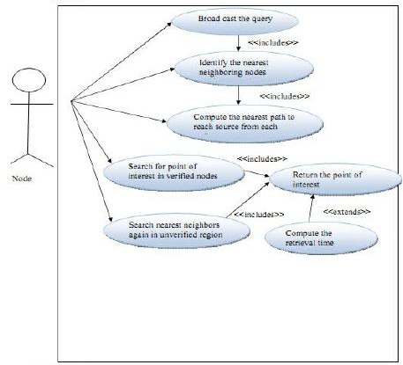

4.4 CLASS DIAGRAM

The class diagram is the main building block in object oriented modelling. It is used both for general conceptual modelling of the systematics of the application, and for detailed modelling translating the models into programming code. The classes in a class diagram represent both the main objects and or interactions in the application and the objects to be programmed. In the class diagram these classes are represented with boxes which contain three parts:
- The upper part holds the name of the class
- The middle part contains the attributes of the class
- The bottom part gives the methods or operations the class can
- take or undertake
In the system design of a system, a number of classes are identified and grouped together in a class diagram which helps to determine the static relations between those objects. With detailed modeling, the classes of the conceptual design are often split into a number of subclasses.

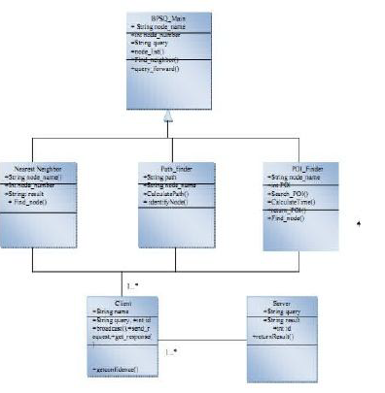
Figure : Class Diagram for module
4.6 Data Flow Diagram for modules
Centralized Server
MH1
MH2
MH3
MH4
MH-Mobile Host

5. IMPLEMENTATION

5.1 IMPLEMENTATION OF THE PROJECT

Implementation is the carrying out, execution, or practice of a plan, a method, or any design for doing something. Implementation is the stage of the project when the theoretical design is turned out into a working system. Thus it can be considered to be the most critical stage in achieving a successful new system and in giving the user, confidence that the new system will work and be effective.

Implementation includes all those activities that take place to convert from the old system to the new. The new system may be totally new, replacing an existing system or it may be major modification to the system currently put into use. This system “Face Recognition” is a new system. Implementation as a whole involves all those tasks that we do for successfully replacing the existing or introduce new software to satisfy the requirement.

The entire work can be described as retrieval of faces from database, processed for eigen faces training method and test case are executed and finally result is displayed to the user. The test case has performed in all aspect and the system has given correct result in all the cases.
Now let’s illustrate each and every screen which were developed

- Centralized Server screen
- Mobile Host1 Screen
- Mobile Host2 Screen
- Mobile Host3 Screen
    - Centralized Server screen

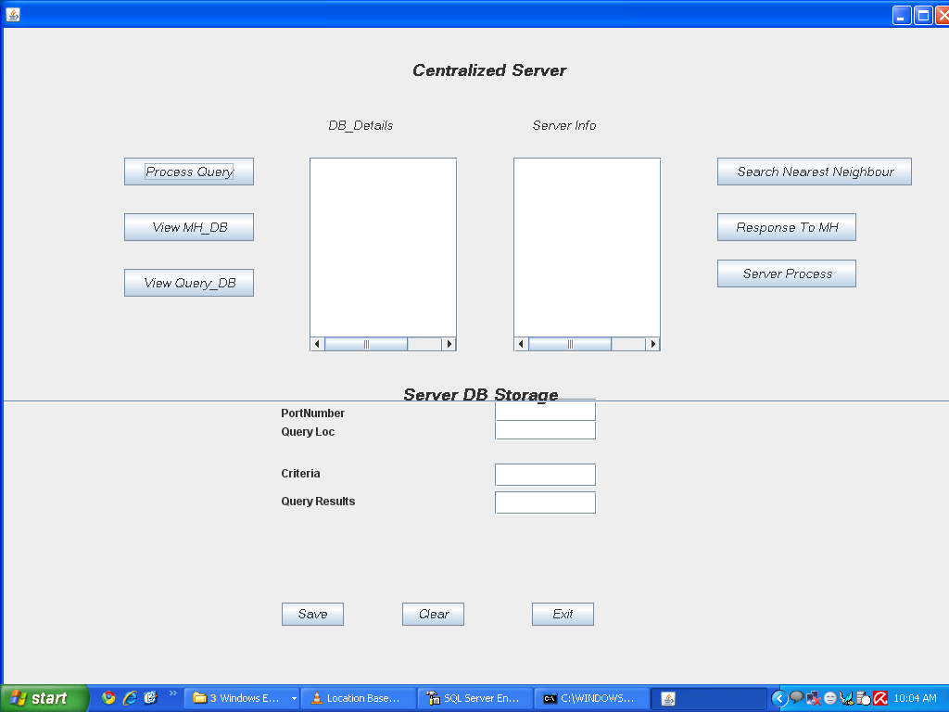

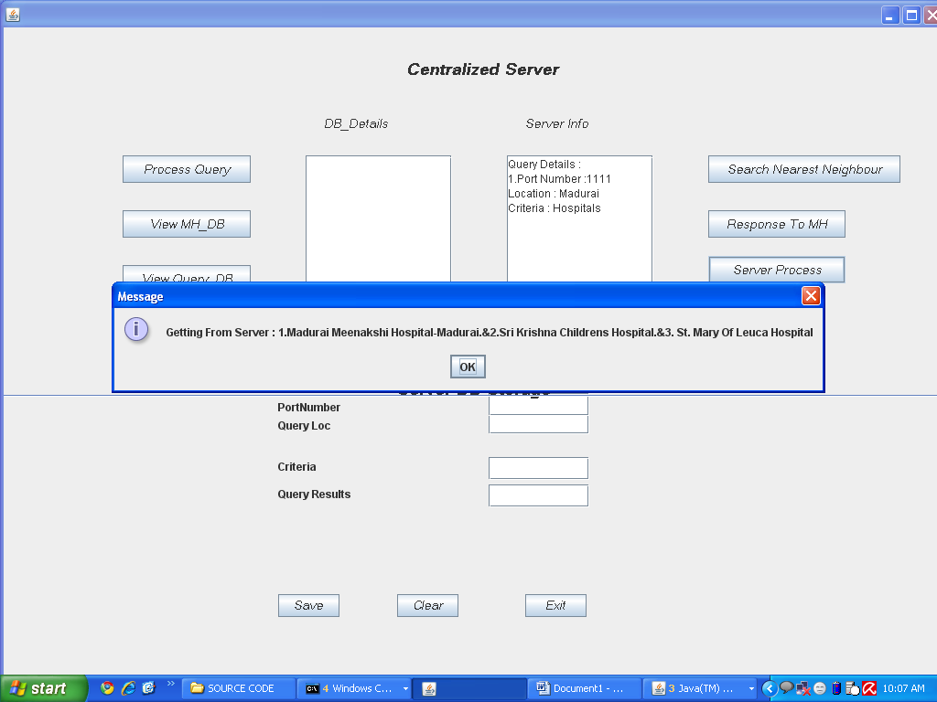

    - Mobile Host1 Screen

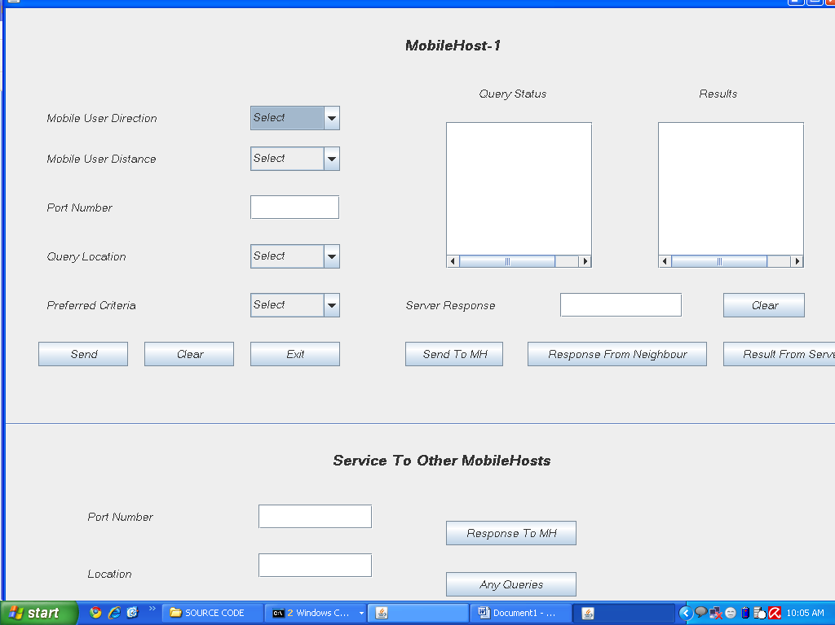

5.1.3 Mobile Host2 Screen

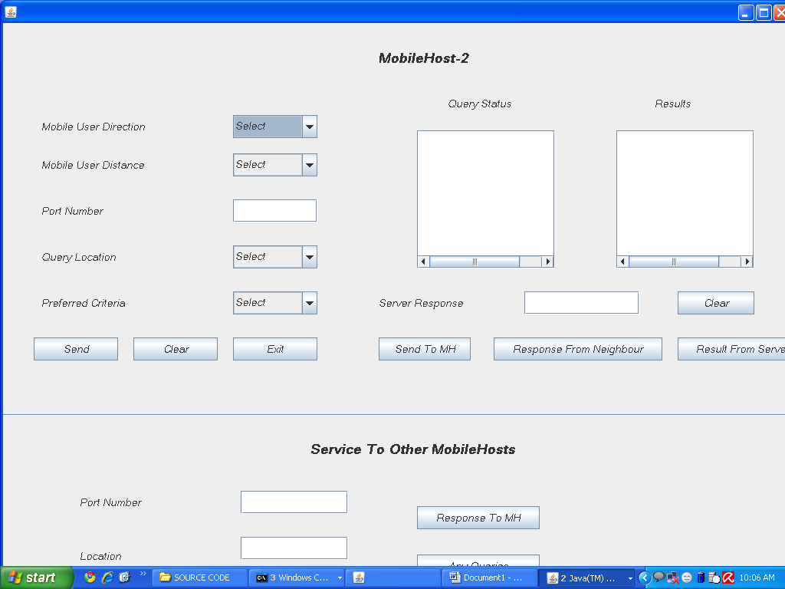

5.1.4 Mobile Host 3 Screen

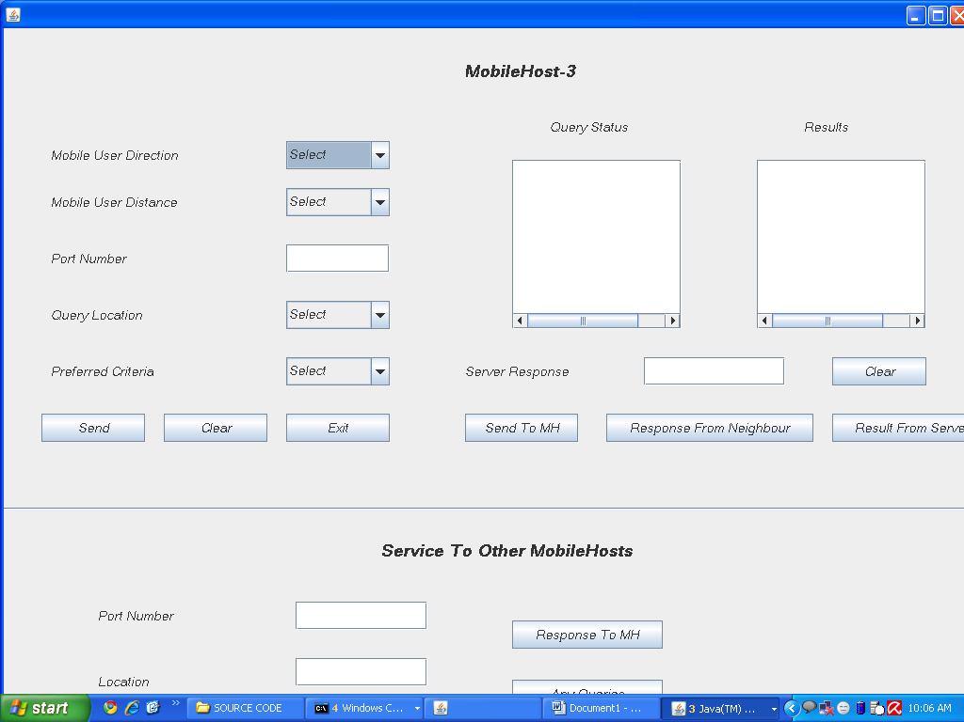

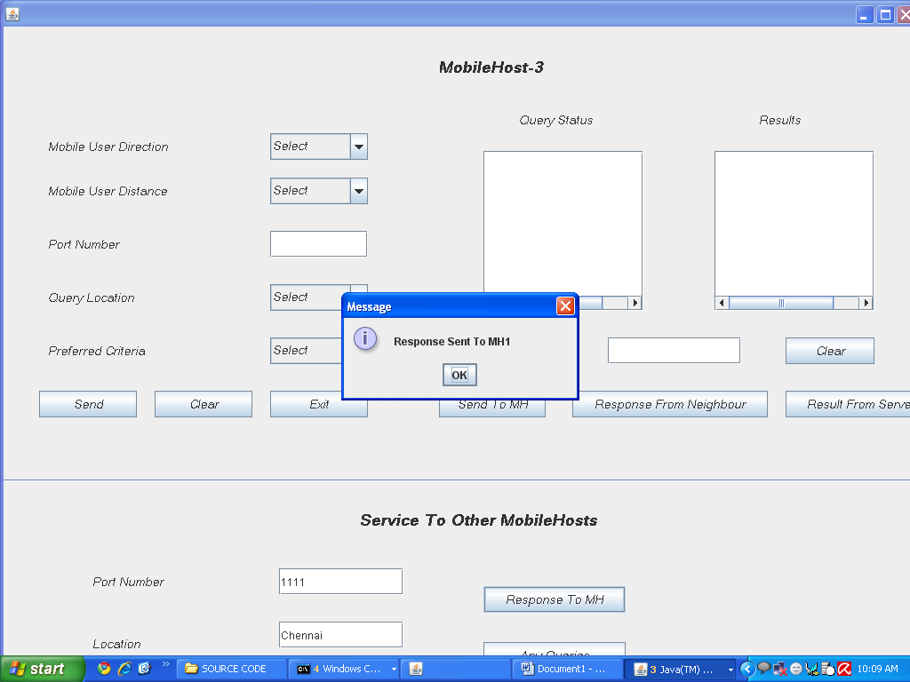

6. CODING

The coding specification should be in such a way that any programmer must be able to understand the code and can bring about changes whenever felt necessary. Some of the standard needed to achieve the above-mentioned objectives are as follows:
- Program should be simple, clear and easy to understand.
- Naming conventions
- Value conventions
- Script and comment procedure
- Message box format
- Exception and error handling

6.1 Centralised Server:

import javax.swing.*;
import java.io.*;
import java.awt.*;
import java.sql.*;
import java.net.*;

/**
*
* @author Admin
*/
public class CentralizedServer extends javax.swing.JFrame {

//ServerSocket ss2;
ServerSocket ss3;
Socket s2,s3;
Socket s4,s6;
Socket s5;
Socket s7;
Socket s8;
Jdbc d = new Jdbc();
int Count = 1;
String[] send;
String[] send1;
String[] send2;

/*String[] pdd0;
String[] pdd1;
String[] pdd2;*/

String portno;
String direction;
String distance;
String location;
String criteria;

ResultSet rs;
/** Creates new form CentralizedServer */
public CentralizedServer() {
initComponents();
setVisible(true);
setSize(1200,1000);
try {

//ss2 = new ServerSocket(7777);
ss3 = new ServerSocket(6666);

} catch (Exception e) {
e.printStackTrace();
}

}

/** This method is called from within the constructor to
* initialize the form.
* WARNING: Do NOT modify this code. The content of this method is
* always regenerated by the Form Editor.
*/
@SuppressWarnings("unchecked")
// <editor-fold defaultstate="collapsed" desc="Generated Code">//GEN-BEGIN:initComponents
private void initComponents() {

jLabel1 = new javax.swing.JLabel();
//jButton1 = new javax.swing.JButton();
jButton2 = new javax.swing.JButton();
jButton3 = new javax.swing.JButton();
jButton4 = new javax.swing.JButton();
jScrollPane1 = new javax.swing.JScrollPane();
jTextArea1 = new javax.swing.JTextArea();
jScrollPane2 = new javax.swing.JScrollPane();
jTextArea2 = new javax.swing.JTextArea();
jLabel2 = new javax.swing.JLabel();
jLabel3 = new javax.swing.JLabel();
//jButton5 = new javax.swing.JButton();
jButton6 = new javax.swing.JButton();
jSeparator1 = new javax.swing.JSeparator();
jButton7 = new javax.swing.JButton();
jButton8 = new javax.swing.JButton();
jLabel4 = new javax.swing.JLabel();
jLabel5 = new javax.swing.JLabel();
jLabel6 = new javax.swing.JLabel();
jLabel7 = new javax.swing.JLabel();
jLabel8 = new javax.swing.JLabel();
jTextField1 = new javax.swing.JTextField();
jTextField2 = new javax.swing.JTextField();
jTextField3 = new javax.swing.JTextField();
jTextField4 = new javax.swing.JTextField();
jButton9 = new javax.swing.JButton();
jButton10 = new javax.swing.JButton();
jButton11 = new javax.swing.JButton();

setDefaultCloseOperation(javax.swing.WindowConstants.EXIT_ON_CLOSE);
getContentPane().setLayout(null);

jLabel1.setFont(new java.awt.Font("Microsoft Sans Serif", 3, 18)); // NOI18N
jLabel1.setText("Centralized Server");
getContentPane().add(jLabel1);
jLabel1.setBounds(440, 30, 190, 30);

/*jButton1.setFont(new java.awt.Font("Microsoft Sans Serif", 2, 14)); // NOI18N
jButton1.setText("Save MH Details");
getContentPane().add(jButton1);
jButton1.setBounds(130, 140, 140, 30);
jButton1.addActionListener(new java.awt.event.ActionListener() {
public void actionPerformed(java.awt.event.ActionEvent evt) {
jButton1ActionPerformed(evt);
}
});*/

jButton2.setFont(new java.awt.Font("Microsoft Sans Serif", 2, 14)); // NOI18N
jButton2.setText("Process Query");
getContentPane().add(jButton2);
jButton2.setBounds(130, 140, 140, 30);
jButton2.addActionListener(new java.awt.event.ActionListener() {
public void actionPerformed(java.awt.event.ActionEvent evt) {
jButton2ActionPerformed(evt);
}
});

jButton3.setFont(new java.awt.Font("Microsoft Sans Serif", 2, 14)); // NOI18N
jButton3.setText("View MH_DB");
getContentPane().add(jButton3);
jButton3.setBounds(130, 200, 140, 30);
jButton3.addActionListener(new java.awt.event.ActionListener() {
public void actionPerformed(java.awt.event.ActionEvent evt) {
jButton3ActionPerformed(evt);
}
});

jButton4.setFont(new java.awt.Font("Microsoft Sans Serif", 2, 14)); // NOI18N
jButton4.setText("View Query_DB");
getContentPane().add(jButton4);
jButton4.setBounds(130, 260, 140, 30);
jButton4.addActionListener(new java.awt.event.ActionListener() {
public void actionPerformed(java.awt.event.ActionEvent evt) {
jButton4ActionPerformed(evt);
}
});

jTextArea1.setColumns(20);
jTextArea1.setRows(5);
jScrollPane1.setViewportView(jTextArea1);

getContentPane().add(jScrollPane1);
jScrollPane1.setBounds(330, 140, 160, 210);

jTextArea2.setColumns(20);
jTextArea2.setRows(5);
jScrollPane2.setViewportView(jTextArea2);

getContentPane().add(jScrollPane2);
jScrollPane2.setBounds(550, 140, 160, 210);

jLabel2.setFont(new java.awt.Font("Microsoft Sans Serif", 2, 14)); // NOI18N
jLabel2.setText("DB_Details");
getContentPane().add(jLabel2);
jLabel2.setBounds(350, 90, 120, 30);

jLabel3.setFont(new java.awt.Font("Microsoft Sans Serif", 2, 14)); // NOI18N
jLabel3.setText("Server Info");
getContentPane().add(jLabel3);
jLabel3.setBounds(570, 90, 120, 30);

/*jButton5.setFont(new java.awt.Font("Microsoft Sans Serif", 2, 14)); // NOI18N
jButton5.setText("Search Nearest Neighbour");
getContentPane().add(jButton5);
jButton5.setBounds(770, 140, 210, 30);
jButton5.addActionListener(new java.awt.event.ActionListener() {
public void actionPerformed(java.awt.event.ActionEvent evt) {
jButton5ActionPerformed(evt);
}
});*/

jButton6.setFont(new java.awt.Font("Microsoft Sans Serif", 2, 14)); // NOI18N
jButton6.setText("Search Nearest Neighbour");
getContentPane().add(jButton6);
jButton6.setBounds(770, 140, 210, 30);
jButton6.addActionListener(new java.awt.event.ActionListener() {
public void actionPerformed(java.awt.event.ActionEvent evt) {
jButton6ActionPerformed(evt);
}
});
getContentPane().add(jSeparator1);
jSeparator1.setBounds(0, 402, 1200, 10);

jButton7.setFont(new java.awt.Font("Microsoft Sans Serif", 2, 14)); // NOI18N
jButton7.setText("Response To MH");
getContentPane().add(jButton7);
jButton7.setBounds(770, 200, 150, 30);
jButton7.addActionListener(new java.awt.event.ActionListener() {
public void actionPerformed(java.awt.event.ActionEvent evt) {
jButton7ActionPerformed(evt);
}
});

jButton8.setFont(new java.awt.Font("Microsoft Sans Serif", 2, 14)); // NOI18N
jButton8.setText("Server Process");
getContentPane().add(jButton8);
jButton8.setBounds(770, 250, 150, 30);
jButton8.addActionListener(new java.awt.event.ActionListener() {
public void actionPerformed(java.awt.event.ActionEvent evt) {
jButton8ActionPerformed(evt);
}
});

jLabel4.setFont(new java.awt.Font("Microsoft Sans Serif", 3, 18)); // NOI18N
jLabel4.setText("Server DB Storage");
getContentPane().add(jLabel4);
jLabel4.setBounds(430, 380, 190, 30);

//jLabel5.setFont(new java.awt.Font("Microsoft Sans Serif", 2, 14)); // NOI18N
jLabel5.setText("PortNumber");
getContentPane().add(jLabel5);
jLabel5.setBounds(300, 400, 150, 30);

//jLabel6.setFont(new java.awt.Font("Microsoft Sans Serif", 2, 14)); // NOI18N
jLabel6.setText("Query Loc");
getContentPane().add(jLabel6);
jLabel6.setBounds(300,420, 130, 30);

//jLabel7.setFont(new java.awt.Font("Microsoft Sans Serif", 2, 14)); // NOI18N
jLabel7.setText("Criteria");
getContentPane().add(jLabel7);
jLabel7.setBounds(300, 470, 140, 20);

//jLabel8.setFont(new java.awt.Font("Microsoft Sans Serif", 2, 14)); // NOI18N
jLabel8.setText("Query Results");
getContentPane().add(jLabel8);
jLabel8.setBounds(300,500, 140, 20);
getContentPane().add(jTextField1);
jTextField1.setBounds(530, 400, 110, 25);
getContentPane().add(jTextField2);
jTextField2.setBounds(530, 420, 110, 25);
getContentPane().add(jTextField3);
jTextField3.setBounds(530, 470, 110, 25);
getContentPane().add(jTextField4);
jTextField4.setBounds(530, 500, 110, 25);

jButton9.setFont(new java.awt.Font("Microsoft Sans Serif", 2, 14)); // NOI18N
jButton9.setText("Save");
getContentPane().add(jButton9);
jButton9.setBounds(300, 620, 67, 25);
jButton9.addActionListener(new java.awt.event.ActionListener() {
public void actionPerformed(java.awt.event.ActionEvent evt) {
jButton9ActionPerformed(evt);
}
});

jButton10.setFont(new java.awt.Font("Microsoft Sans Serif", 2, 14)); // NOI18N
jButton10.setText("Clear");
getContentPane().add(jButton10);
jButton10.setBounds(430, 620, 67, 25);
jButton10.addActionListener(new java.awt.event.ActionListener() {
public void actionPerformed(java.awt.event.ActionEvent evt) {
jButton10ActionPerformed(evt);
}
});

jButton11.setFont(new java.awt.Font("Microsoft Sans Serif", 2, 14)); // NOI18N
jButton11.setText("Exit");
getContentPane().add(jButton11);
jButton11.setBounds(570, 620, 67, 25);
jButton11.addActionListener(new java.awt.event.ActionListener() {
public void actionPerformed(java.awt.event.ActionEvent evt) {
jButton11ActionPerformed(evt);
}
});

pack();
}// </editor-fold>//GEN-END:initComponents

/*private void jButton1ActionPerformed(java.awt.event.ActionEvent evt) {//GEN-FIRST:event_jButton2ActionPerformed
// TODO add your handling code here:
try {
s2 = ss2.accept();
DataInputStream dis = new DataInputStream(s2.getInputStream());
String dd1 = dis.readUTF();
String[] pdd= dd1.split("&");
jTextArea1.append("Mobile User Details :"+"\n");
for (int i = 0; i < pdd.length; i++)
{
String string = pdd[i];
//System.out.println("Total values: "+string);
}
d.insertServer("insert into DD_Details(Portno,Direction,Distance) values('"+pdd[0]+"','"+pdd[1]+"','"+pdd[2]+"')");
jTextArea1.append(Count+"."+"Port Number : "+pdd[0]+"\n");
portno=pdd[0];
direction=pdd[1];
distance=pdd[2];
jTextArea1.append("Direction : "+pdd[1]+"\n");
jTextArea1.append("Distance : "+pdd[2]+"\n");
Count++;

} catch (Exception e) {
e.printStackTrace();
}
}*/

private void jButton2ActionPerformed(java.awt.event.ActionEvent evt) {//GEN-FIRST:event_jButton2ActionPerformed
// TODO add your handling code here:
try {
s3 = ss3.accept();
DataInputStream dis = new DataInputStream(s3.getInputStream());
String dd11= dis.readUTF();
send = dd11.split("&");
jTextArea2.append("Query Details :"+"\n");
for (int i = 0; i < send.length; i++)
{
String string = send[i];
}
//System.out.println(send[0]+""+send[1]+""+send[2]);
d.insertServer("insert into Requested_Hosts values('"+send[0]+"','"+send[1]+"','"+send[2]+"')");
jTextArea2.append(Count+"."+"Port Number :"+send[0]+"\n");
location=send[1];
criteria=send[2];
jTextArea2.append("Location : "+send[1]+"\n");
jTextArea2.append("Criteria : "+send[2]+"\n");
Count++;

} catch (Exception e) {
e.printStackTrace();
}
}

private void jButton3ActionPerformed(java.awt.event.ActionEvent evt) {//GEN-FIRST:event_jButton3ActionPerformed
// TODO add your handling code here:
try {

jTextArea1.append("MH Details: "+"\n"+"Portno Direction Distance "+"\n");
String ss = d.retrive("select * from DD_Details");
String cols[] = ss.split("&");
for (int i = 0; i < cols.length; i++)
{
String string = cols[i];
String[] MH = string.split("%");
for (int j = 0; j < MH.length; j++)
{
String string1 = MH[j];
jTextArea1.append(string1+"\t");
}
jTextArea1.append("\n");

}

} catch (Exception e) {
e.printStackTrace();
}
}

private void jButton4ActionPerformed(java.awt.event.ActionEvent evt) {//GEN-FIRST:event_jButton4ActionPerformed
// TODO add your handling code here:
try {
jTextArea1.append("Query With Results : "+"\n"+"Portno Location Criteria Results "+"\n");
String ss1 = d.retriveResults("select * from Query_Results");
String cols1[] = ss1.split("&");
for (int i = 0; i < cols1.length; i++)
{
String string1 = cols1[i];
String[] QR = string1.split("%");
for (int j = 0; j < QR.length; j++)
{
String string2 = QR[j];
jTextArea1.append(string2+"\t");
}
jTextArea1.append("\n");
}

} catch (Exception e) {
e.printStackTrace();
}
}

/*private void jButton5ActionPerformed(java.awt.event.ActionEvent evt) {//GEN-FIRST:event_jButton2ActionPerformed
// TODO add your handling code here:

System.out.println("Your PortNo :\t"+portno);
System.out.println("Your Direction :\t"+direction);
System.out.println("Your Distance :\t"+distance);
System.out.println("Your Location :\t"+location);
System.out.println("Your Criteria :\t"+criteria);

if(direction.equals("North"))
{
//check with NorthEast and NorthWest
int distancemeasure=0;
/*distance
for (distancemeasure=distance;distancemeasure<100 ;distancemeasure++ )
{
//for km distance
}
}
if(direction.equals("NorthEast"))
{
//check with North and East+
}
if(direction.equals("NorthWest"))
{
//check with North and West and consider distance
}

if(direction.equals("East"))
{
//check with EastNorth and EastWest
}

}*/

private void jButton6ActionPerformed(java.awt.event.ActionEvent evt) {//GEN-FIRST:event_jButton6ActionPerformed
// TODO add your handling code here:
String s0 = send[0];
String s1 = send[1];
String s2 = send[2];
JOptionPane.showMessageDialog(this,s0);
JOptionPane.showMessageDialog(this,s1);
JOptionPane.showMessageDialog(this,s2);

double servertime = System.currentTimeMillis();
System.out.println("Server Time : "+servertime+" ms");

try {
if(s0.equals("1111"))
{
int PortNo = d.retrivePort("select Portno from Query_Results where Location='"+send[1]+"'and Criteria='"+send[2]+"'");
System.out.println("Port Number: "+PortNo);
s5 = new Socket("localhost",4444);
DataOutputStream doutport = new DataOutputStream(s5.getOutputStream());
doutport.writeInt(PortNo);
}
else if(s0.equals("2222"))
{
int PortNo = d.retrivePort("select Portno from Query_Results where Location='"+send[1]+"'and Criteria='"+send[2]+"'");
System.out.println("Port Number: "+PortNo);
s5 = new Socket("localhost",4445);
DataOutputStream doutport = new DataOutputStream(s5.getOutputStream());
doutport.writeInt(PortNo);
}
else if(s0.equals("3333"))
{
int PortNo = d.retrivePort("select Portno from Query_Results where Location='"+send[1]+"'and Criteria='"+send[2]+"'");
System.out.println("Port Number: "+PortNo);
s5 = new Socket("localhost",4446);
DataOutputStream doutport = new DataOutputStream(s5.getOutputStream());
doutport.writeInt(PortNo);

}
}catch (Exception e) {
e.printStackTrace();
}

}

private void jButton7ActionPerformed(java.awt.event.ActionEvent evt) {//GEN-FIRST:event_jButton2ActionPerformed
// TODO add your handling code here:

}

private void jButton8ActionPerformed(java.awt.event.ActionEvent evt) {//GEN-FIRST:event_jButton2ActionPerformed
// TODO add your handling code here:
String ser0 = send[0];
String ser1 = send[1];
String ser2 = send[2];
System.out.println("ser val "+ser0+" "+ser1+" "+ser2);

try
{
if(ser0.equals("1111"))
{
String fromServer = d.gettingResults("select Results from Query_Results where Location = '"+ser1+"' and Criteria = '"+ser2+"' ");
DataOutputStream dosser = new DataOutputStream(s3.getOutputStream());
dosser.writeUTF(fromServer);

}else if(ser0.equals("2222"))
{
String fromServer = d.gettingResults("select Results from Query_Results where Location = '"+ser1+"' and Criteria = '"+ser2+"' ");
DataOutputStream dosser = new DataOutputStream(s3.getOutputStream());
dosser.writeUTF(fromServer);

}else if(ser0.equals("3333"))
{
String fromServer = d.gettingResults("select Results from Query_Results where Location = '"+ser1+"' and Criteria = '"+ser2+"' ");
DataOutputStream dosser = new DataOutputStream(s3.getOutputStream());
dosser.writeUTF(fromServer);
}
}
catch (Exception er)
{
er.printStackTrace();
}

}

private void jButton9ActionPerformed(java.awt.event.ActionEvent evt) {//GEN-FIRST:event_jButton2ActionPerformed
// TODO add your handling code here:
String pno = jTextField1.getText();
String qlc = jTextField2.getText();
String cri = jTextField3.getText();
String rst = jTextField4.getText();

if(pno.equals(""))
{
JOptionPane.showMessageDialog(this,"Enter Port Number");
}
else if(qlc.equals(""))
{
JOptionPane.showMessageDialog(this,"Enter Query Location");
}
else if(cri.equals(""))
{
JOptionPane.showMessageDialog(this,"Enter criteria");
}
else if(rst.equals(""))
{
JOptionPane.showMessageDialog(this,"Enter Results");
}
else if(jButton6!=null)
{
String bu6mess = "Do You Want Save in Database?";

int b4 = JOptionPane.showConfirmDialog(this, bu6mess);
if(b4==0)
{
try {
d.insertServer("insert into Query_Results values('"+pno+"','"+qlc+"','"+cri+"','"+rst+"')");

} catch (Exception e) {
e.printStackTrace();
}

}
}
}

private void jButton10ActionPerformed(java.awt.event.ActionEvent evt) {//GEN-FIRST:event_jButton2ActionPerformed
// TODO add your handling code here:
jTextField1.setText("");
jTextField2.setText("");
jTextField3.setText("");
jTextField4.setText("");
}

private void jButton11ActionPerformed(java.awt.event.ActionEvent evt) {//GEN-FIRST:event_jButton2ActionPerformed
// TODO add your handling code here:

System.exit(0);
}

/**
* @param args the command line arguments
*/
public static void main(String args[]) {

new CentralizedServer();

}

// Variables declaration - do not modify//GEN-BEGIN:variables
private javax.swing.JButton jButton1;
private javax.swing.JButton jButton10;
private javax.swing.JButton jButton11;
private javax.swing.JButton jButton2;
private javax.swing.JButton jButton3;
private javax.swing.JButton jButton4;
private javax.swing.JButton jButton5;
private javax.swing.JButton jButton6;
private javax.swing.JButton jButton7;
private javax.swing.JButton jButton8;
private javax.swing.JButton jButton9;
private javax.swing.JLabel jLabel1;
private javax.swing.JLabel jLabel2;
private javax.swing.JLabel jLabel3;
private javax.swing.JLabel jLabel4;
private javax.swing.JLabel jLabel5;
private javax.swing.JLabel jLabel6;
private javax.swing.JLabel jLabel7;
private javax.swing.JLabel jLabel8;
private javax.swing.JScrollPane jScrollPane1;
private javax.swing.JScrollPane jScrollPane2;
private javax.swing.JSeparator jSeparator1;
private javax.swing.JTextArea jTextArea1;
private javax.swing.JTextArea jTextArea2;
private javax.swing.JTextField jTextField1;
private javax.swing.JTextField jTextField2;
private javax.swing.JTextField jTextField3;
private javax.swing.JTextField jTextField4;
// End of variables declaration//GEN-END:variables

}
6.2 Code for Mobile Hosts:
import javax.swing.*;
:mport java.io.*;
import java.awt.*;
import java.sql.*;
import java.net.*;

/**
*
* @author Admin
*/
public class MobileHost1 extends javax.swing.JFrame {
Connection con;
Statement st;
ServerSocket ss5,ss6,ss7;
String port1;
//Socket s1;
Socket s2;
Socket s3;
Socket s5;
Socket s6;
Socket port;
Socket s7;
Socket s8;
Jdbc d = new Jdbc();
int DD_Count = 1;
int LC_Count = 1;
int getport;
String getplc = "";
double neighbourEndTime, neighbourFinalTime;
double ser,StartTime,serverEndTime,serverFinalTime;

/** Creates new form MobileHost1 */
public MobileHost1() {
initComponents();
setVisible(true);
setSize(1200,1000);

try {
ss5 = new ServerSocket(4444);

ss6 = new ServerSocket(8181);

ss7 = new ServerSocket(1111);

} catch (Exception e) {
e.printStackTrace();
}

prtRecv();

}

/** This method is called from within the constructor to
* initialize the form.
* WARNING: Do NOT modify this code. The content of this method is
* always regenerated by the Form Editor.
*/
@SuppressWarnings("unchecked")
// <editor-fold defaultstate="collapsed" desc="Generated Code">//GEN-BEGIN:initComponents
private void initComponents() {

jLabel1 = new javax.swing.JLabel();
jLabel2 = new javax.swing.JLabel();
jLabel3 = new javax.swing.JLabel();
jLabel4 = new javax.swing.JLabel();
jLabel5 = new javax.swing.JLabel();
jComboBox1 = new javax.swing.JComboBox();
jComboBox2 = new javax.swing.JComboBox();
jTextField1 = new javax.swing.JTextField();
//jButton1 = new javax.swing.JButton();
jComboBox3 = new javax.swing.JComboBox();
jButton2 = new javax.swing.JButton();
jButton3 = new javax.swing.JButton();
jButton4 = new javax.swing.JButton();
jScrollPane1 = new javax.swing.JScrollPane();
jTextArea1 = new javax.swing.JTextArea();
jScrollPane2 = new javax.swing.JScrollPane();
jTextArea2 = new javax.swing.JTextArea();
jLabel6 = new javax.swing.JLabel();
jTextField2 = new javax.swing.JTextField();
jButton5 = new javax.swing.JButton();
jButton6 = new javax.swing.JButton();
jScrollPane3 = new javax.swing.JScrollPane();
jTextArea3 = new javax.swing.JTextArea();
jButton7 = new javax.swing.JButton();
jButton8 = new javax.swing.JButton();
jSeparator1 = new javax.swing.JSeparator();
jLabel7 = new javax.swing.JLabel();
jLabel8 = new javax.swing.JLabel();
jLabel9 = new javax.swing.JLabel();
jLabel10 = new javax.swing.JLabel();
jLabel11 = new javax.swing.JLabel();
jTextField3 = new javax.swing.JTextField();
jLabel12 = new javax.swing.JLabel();
jTextField4 = new javax.swing.JTextField();
jLabel13 = new javax.swing.JLabel();
jTextField5 = new javax.swing.JTextField();
jButton9 = new javax.swing.JButton();
jButton10 = new javax.swing.JButton();
jLabel14 = new javax.swing.JLabel();
jLabel15 = new javax.swing.JLabel();
jComboBox4 = new javax.swing.JComboBox();

setDefaultCloseOperation(javax.swing.WindowConstants.EXIT_ON_CLOSE);
getContentPane().setLayout(null);

jLabel1.setFont(new java.awt.Font("Microsoft Sans Serif", 3, 18));
jLabel1.setText("MobileHost-1");
getContentPane().add(jLabel1);
jLabel1.setBounds(490, 30, 130, 30);

jLabel2.setFont(new java.awt.Font("Microsoft Sans Serif", 2, 14)); // NOI18N
jLabel2.setText("Mobile User Distance");
getContentPane().add(jLabel2);
jLabel2.setBounds(50, 170, 150, 30);

jLabel3.setFont(new java.awt.Font("Microsoft Sans Serif", 2, 14));
jLabel3.setText("Port Number");
getContentPane().add(jLabel3);
jLabel3.setBounds(50, 230, 100, 30);

jLabel4.setFont(new java.awt.Font("Microsoft Sans Serif", 2, 14));
jLabel4.setText("Query Location");
getContentPane().add(jLabel4);
jLabel4.setBounds(50, 290, 110, 30);

jLabel5.setFont(new java.awt.Font("Microsoft Sans Serif", 2, 14));
jLabel5.setText("Preferred Criteria");
getContentPane().add(jLabel5);
jLabel5.setBounds(50, 350, 120, 30);

jComboBox1.setFont(new java.awt.Font("Microsoft Sans Serif", 2, 14)); // NOI18N
jComboBox1.setModel(new javax.swing.DefaultComboBoxModel(new String[] { "Select", "2", "4", "6", "8", "10" }));
jComboBox1.addActionListener(new java.awt.event.ActionListener() {
public void actionPerformed(java.awt.event.ActionEvent evt) {
jComboBox1ActionPerformed(evt);
}
});
getContentPane().add(jComboBox1);
jComboBox1.setBounds(300, 170, 110, 30);

jComboBox2.setFont(new java.awt.Font("Microsoft Sans Serif", 2, 14));
jComboBox2.setModel(new javax.swing.DefaultComboBoxModel(new String[] { "Select", "Chennai", "Madurai", "Trichy", "Vilupuram", "Namakkal" }));
jComboBox2.addActionListener(new java.awt.event.ActionListener() {
public void actionPerformed(java.awt.event.ActionEvent evt) {
jComboBox2ActionPerformed(evt);
}
});
getContentPane().add(jComboBox2);
jComboBox2.setBounds(300, 290, 110, 30);
getContentPane().add(jTextField1);
jTextField1.setBounds(300, 230, 110, 30);

/*jButton1.setFont(new java.awt.Font("Microsoft Sans Serif", 2, 14));
jButton1.setText("Update");
jButton1.addActionListener(new java.awt.event.ActionListener() {
public void actionPerformed(java.awt.event.ActionEvent evt) {
jButton1ActionPerformed(evt);
}
});
getContentPane().add(jButton1);
jButton1.setBounds(300, 230, 110, 30);*/

jComboBox3.setFont(new java.awt.Font("Microsoft Sans Serif", 2, 14));
jComboBox3.setModel(new javax.swing.DefaultComboBoxModel(new String[] { "Select", "Hospitals", "Banks", "Theatres" }));
jComboBox3.addActionListener(new java.awt.event.ActionListener() {
public void actionPerformed(java.awt.event.ActionEvent evt) {
jComboBox3ActionPerformed(evt);
}
});
getContentPane().add(jComboBox3);
jComboBox3.setBounds(300, 350, 110, 30);

jButton2.setFont(new java.awt.Font("Microsoft Sans Serif", 2, 14));
jButton2.setText("Send");
jButton2.addActionListener(new java.awt.event.ActionListener() {
public void actionPerformed(java.awt.event.ActionEvent evt) {
jButton2ActionPerformed(evt);
}
});
getContentPane().add(jButton2);
jButton2.setBounds(40, 410, 110, 30);

jButton3.setFont(new java.awt.Font("Microsoft Sans Serif", 2, 14));
jButton3.setText("Clear");
jButton3.addActionListener(new java.awt.event.ActionListener() {
public void actionPerformed(java.awt.event.ActionEvent evt) {
jButton3ActionPerformed(evt);
}
});
getContentPane().add(jButton3);
jButton3.setBounds(170, 410, 110, 30);

jButton4.setFont(new java.awt.Font("Microsoft Sans Serif", 2, 14));
jButton4.setText("Exit");
jButton4.addActionListener(new java.awt.event.ActionListener() {
public void actionPerformed(java.awt.event.ActionEvent evt) {
jButton4ActionPerformed(evt);
}
});
getContentPane().add(jButton4);
jButton4.setBounds(300, 410, 110, 30);

/*jTextArea1.setColumns(20);
jTextArea1.setRows(5);
jScrollPane1.setViewportView(jTextArea1);

getContentPane().add(jScrollPane1);
jScrollPane1.setBounds(490, 140, 160, 170);*/

jTextArea2.setColumns(20);
jTextArea2.setRows(5);
jScrollPane2.setViewportView(jTextArea2);

getContentPane().add(jScrollPane2);
jScrollPane2.setBounds(540, 140, 180, 180);

jLabel6.setFont(new java.awt.Font("Microsoft Sans Serif", 2, 14));
jLabel6.setText("Server Response");
getContentPane().add(jLabel6);
jLabel6.setBounds(490, 350, 130, 30);
getContentPane().add(jTextField2);
jTextField2.setBounds(680, 350, 150, 30);

jButton5.setFont(new java.awt.Font("Microsoft Sans Serif", 2, 14));
jButton5.setText("Send To MH");
jButton5.addActionListener(new java.awt.event.ActionListener() {
public void actionPerformed(java.awt.event.ActionEvent evt) {
jButton5ActionPerformed(evt);
}
});
getContentPane().add(jButton5);
jButton5.setBounds(490, 410, 120, 30);

jButton6.setFont(new java.awt.Font("Microsoft Sans Serif", 2, 14));
jButton6.setText("Response From Neighbour");
jButton6.addActionListener(new java.awt.event.ActionListener() {
public void actionPerformed(java.awt.event.ActionEvent evt) {
jButton6ActionPerformed(evt);
}
});
getContentPane().add(jButton6);
jButton6.setBounds(640, 410, 220, 30);

jTextArea3.setColumns(20);
jTextArea3.setRows(5);
jScrollPane3.setViewportView(jTextArea3);

getContentPane().add(jScrollPane3);
jScrollPane3.setBounds(800, 140, 180, 180);

jButton7.setFont(new java.awt.Font("Microsoft Sans Serif", 2, 14));
jButton7.setText("Clear");
jButton7.addActionListener(new java.awt.event.ActionListener() {
public void actionPerformed(java.awt.event.ActionEvent evt) {
jButton7ActionPerformed(evt);
}
});
getContentPane().add(jButton7);
jButton7.setBounds(880, 350, 100, 30);

jButton8.setFont(new java.awt.Font("Microsoft Sans Serif", 2, 14));
jButton8.setText("Result From Server");
jButton8.addActionListener(new java.awt.event.ActionListener() {
public void actionPerformed(java.awt.event.ActionEvent evt) {
jButton8ActionPerformed(evt);
}
});
getContentPane().add(jButton8);
jButton8.setBounds(880, 410, 170, 30);
getContentPane().add(jSeparator1);
jSeparator1.setBounds(0, 510, 1210, 20);

/*jLabel7.setFont(new java.awt.Font("Microsoft Sans Serif", 2, 14));
jLabel7.setText("Update Info");
getContentPane().add(jLabel7);
jLabel7.setBounds(520, 90, 120, 30);*/

jLabel8.setFont(new java.awt.Font("Microsoft Sans Serif", 2, 14));
jLabel8.setText("Query Status");
getContentPane().add(jLabel8);
jLabel8.setBounds(580, 90, 120, 30);

jLabel9.setFont(new java.awt.Font("Microsoft Sans Serif", 2, 14));
jLabel9.setText("Results");
getContentPane().add(jLabel9);
jLabel9.setBounds(850, 90, 120, 30);

jLabel10.setFont(new java.awt.Font("Microsoft Sans Serif", 3, 18));
jLabel10.setText("Service To Other MobileHosts");
getContentPane().add(jLabel10);
jLabel10.setBounds(400, 540, 300, 30);

jLabel11.setFont(new java.awt.Font("Microsoft Sans Serif", 2, 14));
jLabel11.setText("Port Number");
getContentPane().add(jLabel11);
jLabel11.setBounds(100, 610, 140, 30);
getContentPane().add(jTextField3);
jTextField3.setBounds(310, 610, 140, 30);

jLabel12.setFont(new java.awt.Font("Microsoft Sans Serif", 2, 14));
jLabel12.setText("Location");
getContentPane().add(jLabel12);
jLabel12.setBounds(100, 680, 120, 30);
getContentPane().add(jTextField4);
jTextField4.setBounds(310, 670, 140, 30);

jLabel13.setFont(new java.awt.Font("Microsoft Sans Serif", 2, 14));
jLabel13.setText("Criteria");
getContentPane().add(jLabel13);
jLabel13.setBounds(100, 730, 100, 30);
getContentPane().add(jTextField5);
jTextField5.setBounds(310, 730, 140, 30);

jButton9.setFont(new java.awt.Font("Microsoft Sans Serif", 2, 14));
jButton9.setText("Response To MH");
jButton9.addActionListener(new java.awt.event.ActionListener() {
public void actionPerformed(java.awt.event.ActionEvent evt) {
jButton9ActionPerformed(evt);
}
});
getContentPane().add(jButton9);
jButton9.setBounds(540, 630, 160, 30);

jButton10.setFont(new java.awt.Font("Microsoft Sans Serif", 2, 14));
jButton10.setText("Any Queries");
jButton10.addActionListener(new java.awt.event.ActionListener() {
public void actionPerformed(java.awt.event.ActionEvent evt) {
jButton10ActionPerformed(evt);
}
});
getContentPane().add(jButton10);
jButton10.setBounds(540, 693, 160, 30);

jLabel14.setFont(new java.awt.Font("Microsoft Sans Serif", 2, 14));
jLabel14.setText("MH - Mobile Host");
getContentPane().add(jLabel14);
jLabel14.setBounds(1020, 760, 120, 20);

jLabel15.setFont(new java.awt.Font("Microsoft Sans Serif", 2, 14)); // NOI18N
jLabel15.setText("Mobile User Direction");
getContentPane().add(jLabel15);
jLabel15.setBounds(50, 120, 140, 30);

jComboBox4.setFont(new java.awt.Font("Microsoft Sans Serif", 2, 14)); // NOI18N
jComboBox4.setModel(new javax.swing.DefaultComboBoxModel(new String[] { "Select", "North", "South", "East", "West" }));
getContentPane().add(jComboBox4);
jComboBox4.setBounds(300, 120, 110, 30);

pack();
}// </editor-fold>//GEN-END:initComponents

public void prtRecv()
{
while(true)
{
try {
port = ss5.accept();
JOptionPane.showMessageDialog(this,"Port Received ");
DataInputStream disport = new DataInputStream(port.getInputStream());
getport = disport.readInt();
jTextField2.setText(""+getport);

}catch (Exception r) {
r.printStackTrace();
}
}

}

public void prefinalres()
{
try
{
s6 = ss7.accept();
JOptionPane.showMessageDialog(this,"Request Comes");
DataInputStream displc = new DataInputStream(s6.getInputStream());
getplc = displc.readUTF();
String getplc1[] = getplc.split("&");
for (int i = 0; i < getplc1.length; i++)
{
String string = getplc1[i];
}

jTextField3.setText(getplc1[3]);
jTextField4.setText(getplc1[1]);
jTextField5.setText(getplc1[2]);

}catch (Exception r)
{
r.printStackTrace();
}
}

public void rstRecv()
{
try
{
s5 = ss6.accept();
DataInputStream disrst = new DataInputStream(s5.getInputStream());
String getrst = (disrst.readUTF()).trim();
String arrstrfinal[] = getrst.split("&");
for (int i=0; i<arrstrfinal.length;i++ )
{
String one = arrstrfinal[i];

}
JOptionPane.showMessageDialog(this,"Getting Response");
jTextArea3.setText("The Result For Requested Query : \n");
jTextArea3.append(""+arrstrfinal[0]+"\n");
jTextArea3.append(""+arrstrfinal[1]+"\n");
jTextArea3.append(""+arrstrfinal[2]+"\n");

}catch (Exception r) {
r.printStackTrace();
}
}
private void jComboBox1ActionPerformed(java.awt.event.ActionEvent evt) {//GEN-FIRST:event_jComboBox1ActionPerformed
// TODO add your handling code here:
}//GEN-LAST:event_jComboBox1ActionPerformed

private void jComboBox2ActionPerformed(java.awt.event.ActionEvent evt) {//GEN-FIRST:event_jComboBox2ActionPerformed
// TODO add your handling code here:
}//GEN-LAST:event_jComboBox2ActionPerformed

private void jComboBox3ActionPerformed(java.awt.event.ActionEvent evt) {//GEN-FIRST:event_jComboBox3ActionPerformed
// TODO add your handling code here:
}//GEN-LAST:event_jComboBox3ActionPerformed

private void jButton4ActionPerformed(java.awt.event.ActionEvent evt) {//GEN-FIRST:event_jButton4ActionPerformed
// TODO add your handling code here:
System.exit(0);
}//GEN-LAST:event_jButton4ActionPerformed

/*private void jButton1ActionPerformed(java.awt.event.ActionEvent evt) {//GEN-FIRST:event_jButton1ActionPerformed
// TODO add your handling code here:
String tf1 = jTextField1.getText();
String cb1 = ""+jComboBox1.getSelectedItem();
String cb2 = ""+jComboBox4.getSelectedItem();

if(cb2.equals("Select"))
{
String cb3mess = "Plz Enter the Direction";
JOptionPane.showMessageDialog(this,cb3mess);
}
else if(cb1.equals("Select"))
{
String cb2mess = "Plz Enter the Distance";
JOptionPane.showMessageDialog(this,cb2mess);
}
else if(tf1.equals(""))
{
JOptionPane.showMessageDialog(this,"Enter PortNo");
}
else if(jButton1!=null)
{
String bu1mess = "Do You Want Update?";
String bu11mess = "User Information Updated!!"+"\n";
int b1 = JOptionPane.showConfirmDialog(this, bu1mess);

if(b1==0)
{
jTextArea1.append(DD_Count+"."+bu11mess);
}
DD_Count++;

try {
s1 = new Socket("localhost",7777);
DataOutputStream dos = new DataOutputStream(s1.getOutputStream());
String dd = tf1+"&"+cb1+"&"+cb2;
dos.writeUTF(dd);

} catch (Exception e) {
e.printStackTrace();
}
}

}//GEN-LAST:event_jButton1ActionPerformed*/

private void jButton2ActionPerformed(java.awt.event.ActionEvent evt) {//GEN-FIRST:event_jButton2ActionPerformed
// TODO add your handling code here:
String tf1 = jTextField1.getText();
String cb2 = ""+jComboBox2.getSelectedItem();
String cb3 = ""+jComboBox3.getSelectedItem();

StartTime = System.currentTimeMillis();
System.out.println("Start Time : "+StartTime+" ms \n");

/*String cb1 = ""+jComboBox1.getSelectedItem();
System.out.println(""+cb1);
if(cb1.equals("Select"))
{
JOptionPane.showMessageDialog(this,"Enter Distance");
}*/
if(tf1.equals(""))
{
String tf1mess = "Plz Enter the PortNumber";
JOptionPane.showMessageDialog(this,tf1mess);
}
else if(cb2.equals("Select"))
{
String cb2mess = "Plz Enter the Location";
JOptionPane.showMessageDialog(this,cb2mess);
}
else if(cb3.equals("Select"))
{
String cb3mess = "Plz Enter the Criteria";
JOptionPane.showMessageDialog(this,cb3mess);
}
else if(jButton4!=null)
{
String bu4mess = "Do You Want To proces the Query?";
String bu44mess = "Query Sent To Server!!"+"\n";
int b4 = JOptionPane.showConfirmDialog(this, bu4mess);
if(b4==0)
{
jTextArea2.append(LC_Count+"."+bu44mess);
}
LC_Count++;

try {
s2 = new Socket("localhost",6666);
String send = tf1+"&"+cb2+"&"+cb3;
DataOutputStream dos = new DataOutputStream(s2.getOutputStream());
dos.writeUTF(send);
System.out.println("ss "+send+" "+cb2+" "+cb3);
} catch (Exception e) {
e.printStackTrace();
}
}

}//GEN-LAST:event_jButton2ActionPerformed

private void jButton3ActionPerformed(java.awt.event.ActionEvent evt) {//GEN-FIRST:event_jButton3ActionPerformed
// TODO add your handling code here:
jTextField1.setText("");
jComboBox2.setSelectedItem("Select");
jComboBox3.setSelectedItem("Select");

}//GEN-LAST:event_jButton3ActionPerformed

private void jButton5ActionPerformed(java.awt.event.ActionEvent evt) {//GEN-FIRST:event_jButton5ActionPerformed
// TODO add your handling code here:
String po = jTextField2.getText();
String cb333 = ""+jComboBox2.getSelectedItem();
String cb444 = ""+jComboBox3.getSelectedItem();
String po1 = jTextField1.getText();

try {

if(po.equals("2222"))
{
s3 = new Socket("localhost",2222);
String resSend2 = po+"&"+cb333+"&"+cb444+"&"+po1;
DataOutputStream dousres2 = new DataOutputStream(s3.getOutputStream());
dousres2.writeUTF(resSend2);
JOptionPane jp=new JOptionPane();
jp.showConfirmDialog(jp,"Do You Want Send Query To Nearest MobileHost2");
}
else if(po.equals("3333"))
{
s3 = new Socket("localhost",3333);
String resSend3 = po+"&"+cb333+"&"+cb444+"&"+po1;
DataOutputStream dousres3 = new DataOutputStream(s3.getOutputStream());
dousres3.writeUTF(resSend3);
JOptionPane jp=new JOptionPane();
jp.showConfirmDialog(jp,"Do You Want Send Query To Nearest MobileHost3");
}
} catch (Exception e) {
e.printStackTrace();
}

}//GEN-LAST:event_jButton5ActionPerformed

private void jButton6ActionPerformed(java.awt.event.ActionEvent evt) {//GEN-FIRST:event_jButton6ActionPerformed
// TODO add your handling code here:
neighbourEndTime = System.currentTimeMillis();
System.out.println("Neighbour End Time : "+neighbourEndTime+" ms \n");
neighbourFinalTime = neighbourEndTime - StartTime;
System.out.println("Neighbour Final Time : "+neighbourFinalTime+" ms \n");
rstRecv();
}//GEN-LAST:event_jButton6ActionPerformed

private void jButton7ActionPerformed(java.awt.event.ActionEvent evt) {//GEN-FIRST:event_jButton7ActionPerformed
// TODO add your handling code here:
}//GEN-LAST:event_jButton7ActionPerformed

private void jButton8ActionPerformed(java.awt.event.ActionEvent evt) {double ser = System.currentTimeMillis();
double serverEndTime = ser+100000;//GEN-FIRST:event_jButton8ActionPerformed
// TODO add your handling code here:

System.out.println("Server FinalTime : "+serverEndTime+" ms \n");
serverFinalTime = serverEndTime - StartTime;
System.out.println("FinalTime From Client To Server : "+serverFinalTime+" ms \n");

try
{
DataInputStream disser = new DataInputStream(s2.getInputStream());
String resultvalue = (disser.readUTF()).trim();
String newresult[] = resultvalue.split("&");
for (int i=0; i<newresult.length;i++ )
{
String one = newresult[i];
}
JOptionPane.showMessageDialog(this,"Getting Results");
jTextArea3.setText("Result For Query: \n");
jTextArea3.append(newresult[0]+"\n");
jTextArea3.append(newresult[1]+"\n");
jTextArea3.append(newresult[2]+"\n");

}catch (Exception er) {
er.printStackTrace();
}

}//GEN-LAST:event_jButton8ActionPerformed

private void jButton9ActionPerformed(java.awt.event.ActionEvent evt) {//GEN-FIRST:event_jButton9ActionPerformed
// TODO add your handling code here:
String strfinal1 = jTextField3.getText();
String strfinal2 = jTextField4.getText();
String strfinal3 = jTextField5.getText();

try
{
if(strfinal1.equals("2222"))
{
String strfinal = d.retriveFinalrst("select Results from MH1 where Location='"+strfinal2+"' and Criteria='"+strfinal3+"' ");
System.out.println("---------------->"+strfinal);
s8 = new Socket("localhost",8282);
DataOutputStream doutff2 = new DataOutputStream(s8.getOutputStream());
doutff2.writeUTF(strfinal);
JOptionPane.showMessageDialog(this,"Response Sent To MH1");

}else if(strfinal1.equals("3333"))
{
String strfinal = d.retriveFinalrst("select Results from MH1 where Location='"+strfinal2+"' and Criteria='"+strfinal3+"' ");
System.out.println("---------------->"+strfinal);
s8 = new Socket("localhost",8383);
DataOutputStream doutff3 = new DataOutputStream(s8.getOutputStream());
doutff3.writeUTF(strfinal);
JOptionPane.showMessageDialog(this,"Response Sent To MH3");
}
}catch (Exception er) {
er.printStackTrace();
}

}//GEN-LAST:event_jButton9ActionPerformed

private void jButton10ActionPerformed(java.awt.event.ActionEvent evt) {//GEN-FIRST:event_jButton10ActionPerformed
// TODO add your handling code here:
prefinalres();
}//GEN-LAST:event_jButton10ActionPerformed

/**
* @param args the command line arguments
*/
public static void main(String args[]) {

new MobileHost1();

}

// Variables declaration - do not modify//GEN-BEGIN:variables
private javax.swing.JButton jButton1;
private javax.swing.JButton jButton10;
private javax.swing.JButton jButton2;
private javax.swing.JButton jButton3;
private javax.swing.JButton jButton4;
private javax.swing.JButton jButton5;
private javax.swing.JButton jButton6;
private javax.swing.JButton jButton7;
private javax.swing.JButton jButton8;
private javax.swing.JButton jButton9;
private javax.swing.JComboBox jComboBox1;
private javax.swing.JComboBox jComboBox2;
private javax.swing.JComboBox jComboBox3;
private javax.swing.JComboBox jComboBox4;
private javax.swing.JLabel jLabel1;
private javax.swing.JLabel jLabel10;
private javax.swing.JLabel jLabel11;
private javax.swing.JLabel jLabel12;
private javax.swing.JLabel jLabel13;
private javax.swing.JLabel jLabel14;
private javax.swing.JLabel jLabel15;
private javax.swing.JLabel jLabel2;
private javax.swing.JLabel jLabel3;
private javax.swing.JLabel jLabel4;
private javax.swing.JLabel jLabel5;
private javax.swing.JLabel jLabel6;
private javax.swing.JLabel jLabel7;
private javax.swing.JLabel jLabel8;
private javax.swing.JLabel jLabel9;
private javax.swing.JScrollPane jScrollPane1;
private javax.swing.JScrollPane jScrollPane2;
private javax.swing.JScrollPane jScrollPane3;
private javax.swing.JSeparator jSeparator1;
private javax.swing.JTextArea jTextArea1;
private javax.swing.JTextArea jTextArea2;
private javax.swing.JTextArea jTextArea3;
private javax.swing.JTextField jTextField1;
private javax.swing.JTextField jTextField2;
private javax.swing.JTextField jTextField3;
private javax.swing.JTextField jTextField4;
private javax.swing.JTextField jTextField5;
// End of variables declaration//GEN-END:variables

6.3 Code For Database:
import javax.swing.*;
import java.io.*;
import java.awt.*;
import java.sql.*;

class Jdbc
{
// insert Client Method Calls
public String insertClient(String query)
{
try {

Class.forName("sun.jdbc.odbc.JdbcOdbcDriver");
Connection con = DriverManager.getConnection("jdbc:odbc:Mobile");
System.out.println("CONNECTED");
Statement st = con.createStatement();
st.executeUpdate(query);

} catch (Exception e) {
System.out.println("Connection Not Found"+e);
}
return "";
}

// insert Server Method Calls
public String insertServer(String query)
{
try {

Class.forName("sun.jdbc.odbc.JdbcOdbcDriver");
Connection con = DriverManager.getConnection("jdbc:odbc:MobileServer");
Statement st = con.createStatement();
st.executeUpdate(query);

} catch (Exception e) {
System.out.println("Connection Not Found"+e);
}
return "";
}

// retrive Method Calls
public String retrive(String query)
{
String values = "";

try {

Class.forName("sun.jdbc.odbc.JdbcOdbcDriver");
Connection con = DriverManager.getConnection("jdbc:odbc:MobileServer");
Statement st = con.createStatement();
ResultSet rs = st.executeQuery(query);
while(rs.next())
{
values += rs.getString("Portno")+"%"+ rs.getString("Direction")+"%"+rs.getString("Distance")+"&";
}

} catch (Exception e) {
e.printStackTrace();
}
return values;
}

// retriveResults Method Calls

public String retriveResults(String query)
{
String rsts = "";

try {

Class.forName("sun.jdbc.odbc.JdbcOdbcDriver");
Connection con = DriverManager.getConnection("jdbc:odbc:MobileServer");
Statement st = con.createStatement();
ResultSet rs = st.executeQuery(query);
while(rs.next())
{
rsts += rs.getString("Portno")+"%"+ rs.getString("Location")+"%"+rs.getString("Criteria")+"%"+rs.getString("Results")+"&";
}

} catch (Exception e) {

e.printStackTrace();
}
return rsts;
}

// retrive Method Calls
public String retriveFinalrst(String query)
{
String finalrst = "";

try {

Class.forName("sun.jdbc.odbc.JdbcOdbcDriver");
Connection con = DriverManager.getConnection("jdbc:odbc:Mobile");
Statement st = con.createStatement();
ResultSet rs = st.executeQuery(query);
while(rs.next())
{
finalrst += rs.getString(1);
}

} catch (Exception e) {

e.printStackTrace();
}
return finalrst;
}

// Search Method Calls

public int search(String query)
{
int searchResults=0;
try {

Class.forName("sun.jdbc.odbc.JdbcOdbcDriver");
Connection con = DriverManager.getConnection("jdbc:odbc:MobileServer");
Statement st = con.createStatement();
ResultSet rs=st.executeQuery(query);
while(rs.next())
{
searchResults=rs.getInt(1);
}
System.out.println(searchResults);

JOptionPane jp=new JOptionPane();
jp.showMessageDialog(jp,"Min Distance : "+searchResults);

} catch (Exception e) {
e.printStackTrace();
}
return searchResults;
}

// retrivePort Method Calls

public int retrivePort(String query)
{
int port =0;

try {

Class.forName("sun.jdbc.odbc.JdbcOdbcDriver");
Connection con = DriverManager.getConnection("jdbc:odbc:MobileServer");
Statement st = con.createStatement();
ResultSet rs = st.executeQuery(query);
if(rs.next()==true)
{
port+= rs.getInt(1);
JOptionPane jp=new JOptionPane();
jp.showMessageDialog(jp,"Port Number : "+port);

}

} catch (Exception e) {
e.printStackTrace();
}
return port;
}

// retriveMH2db Method Calls

public String retriveMH2db(String query)
{
String rst1 = "";

try {

Class.forName("sun.jdbc.odbc.JdbcOdbcDriver");
Connection con = DriverManager.getConnection("jdbc:odbc:Mobile");
Statement st = con.createStatement();
ResultSet rs = st.executeQuery(query);
while(rs.next())
{
rst1 += rs.getString("Results");
JOptionPane jp=new JOptionPane();
jp.showConfirmDialog(jp,"Do You Want Send Query To Nearest MobileHost");

}

} catch (Exception e) {
e.printStackTrace();
}
return rst1;
}

public String gettingResults(String query)
{
String onlyServer="";
try {

Class.forName("sun.jdbc.odbc.JdbcOdbcDriver");
Connection con = DriverManager.getConnection("jdbc:odbc:MobileServer");
Statement st = con.createStatement();
ResultSet rs=st.executeQuery(query);
while(rs.next())
{
onlyServer=rs.getString("Results");
}
System.out.println(onlyServer);

JOptionPane jp=new JOptionPane();
jp.showMessageDialog(jp,"Getting From Server : "+onlyServer);

} catch (Excepti
e.printStackTrace();
}
return onlyServer;
}

public String neighbourSearch(String query)
{
String rtnport="";
try {

Class.forName("sun.jdbc.odbc.JdbcOdbcDriver");
Connection con = DriverManager.getConnection("jdbc:odbc:MobileServer");
Statement st = con.createStatement();
ResultSet rs=st.executeQuery(query);
while(rs.next())
{
rtnport=rs.getString("Portno");
}
System.out.println(rtnport);
JOptionPane jp=new JOptionPane();
jp.showMessageDialog(jp,"Neighbour Port : "+rtnport);

} catch (Exception e) {
e.printStackTrace();
}
return rtnport;
}
public static void main(String[] args)
anew Jdbc();}}

7. TESTING

Testing is the process of finding differences between the expected behavior specified by system models and the observed behavior of the system. Testing is a critical role in quality assurance and ensuring the reliability of development and these errors will be reflected in the code so the application should be thoroughly tested and validated.
Unit testing finds the differences between the object design model and its corresponding components. Structural testing finds differences between the system design model and a subset of integrated subsystems. Functional testing finds differences between the use case model and the system.
Finally performance testing, finds differences between non-functional requirements and actual system performance. From modeling point of view, testing is the attempt of falsification of the system with respect to the system models. The goal of testing is to design tests that exercise defects in the system and to reveal problems.
7.1 TESTING CONCEPTS
A component is a part of the system that can be isolated for testing. A component can be an object, a group of objects (or) one (or) behaviorA fault is a design or coding mistake that may cause abnormal component behavior
An error is a manifestation of a fault during the execution of the system
A failure is a deviation between the specification of a component and its behavior. A failure is triggered by one or more errors
A test case is a set of inputs and expected results that exercise a component with the purpose of causing failures and deleting faults
A test stub is a partial implementation of components on which the test component depends. A test driver is a partial implementation of a component. Test stubs are drivers enables to be isolated from the system for testing
A correction is a change to a component the purpose of a correction is to repair a fault.
7.2 TESTING ACTIVITIES
Testing a large system is a complex activity and like any complex activity. It has to be broke into smaller activities. Thus incremental testing was performed on the project i.e., components and subsystems of the system were tested separately before integrating them to form the subsystem for system testing.
7.2.1 Unit Testing
Unit testing focuses on the building blocks of the software system that is the objects and subsystems. There are three motivations behind focusing on components. First unit testing reduces the complexity of overall test activities allowing focus on smaller units of the system, second unit testing makes it easier to pinpoint and correct faults given that few components are involved in the rest. Third unit testing allows parallelism in the testing activities, that is each component are involved in the test. Third unit testing allows parallelism in the testing activities that is each component can be tested independently of one another.The following are some unit testing techniques.

7.2.2 Equivalence Testing
It is a black box testing technique that minimizes the number of test cases. The possible inputs are partitioned into equivalence classes and a test case is selected for each class.
Ex: In this project in Login figure if User doesn’t select any of state it will display the error message that ”Select Input File ”. This is achieved through equivalence testing.
7.2.3 Boundary Testing
It is a special case of equivalence testing and focuses on the conditions at the boundary of the equivalence classes. Boundary testing requires that the elements be selected from the edges of the equivalence classes.
Ex: In this project, if user selects very small images then system displays the errors, because the boundary conditions are not satisfied for the given input.

7.2.4 Path testing
It is a white box testing technique that identifies faults in the implementation of the component the assumption here is that exercising all possible paths through the code at least once. Most faults will trigger failure. This acquires knowledge of source code.

7.2.5 Integration Testing
Many tested modules are combined into subsystem. Which are then tested? The emphasis is on testing interface between modules. This activity can be considered to test the design.
Ex: We first perform individual testing on the modules. Later some modules like Pre-processing and Canonical Correlations and then validating the results are all integrated into a component and tested as a single unit.
7.2.5 Validation Testing
The systems completely assembled as package, the interfacing have been uncovered and corrected, and a final series of software tests are validation testing. The validation testing is nothing but validation success when system functions in a manner that can be reasonably expected by the customer. The system validation had done by series of Black-box test methods.
7.2.6 System Testing
This is a series of testing whose purpose is to fully exercise the entire software system. System testing verifies that all elements mesh properly and the overall system function/performance is achieved. System testing is done using real data. The system performance was found to be working to be as per requirements specified.

7.3 TESTING APPROACHES
There are two basic approaches to testing:
a) Functional (Black box testing)
c) Structural (White box testing)

7.3.1 White box Testing
This test focuses on the program control structure. Test cases are derived to ensure that all the statements in the program have been executed at least once during testing and that all logical conditions have been exercised.
Ex: In this project, in Canonical Correlation figure if we not mention the Path of image it will show “File not Found” error. This is achieved through White box testing.

7.3.2 Black box Testing
These tests are designed to validate functional requirements without regard to working of the program. Black box testing technique focuses on the information domain of the software deriving test cases by partitioning input and output in a manner that provides thorough test coverage. This approach also deals with the identification of class libraries or software packages or other application systems, which are already present so that developer .
8. CONCLUSION

This project presents a novel approach for reducing the spatial query access latency by leveraging results from nearby peers in wireless broadcast environments. Significantly, our scheme allows a mobile client to locally verify whether candidate objects received from peers are indeed part of its own spatial query result set. The experiment results indicate that our method can reduce the access to the wireless broadcast channel by a significant amount, for example, up to 80 percent, in a dense urban area. This is achieved with minimal caching at the peers. By virtue of its P2P architecture, the method exhibits great scalability: the higher the mobile peer density, the more the queries answered by peers. Therefore, the query access latency can be markedly decreased with the increase in clients.

9. REFERENCES

- W.-S. Ku and R. Zimmermann, “Location-Based Spatial Queries
with Data Sharing in Mobile Environments,” Proc. 22nd IEEE Int’l
Conf. Data Eng. (ICDE ’06) Workshops, p. 140, 2006.

2. B. Zheng, W.-C. Lee, and D. Lun Lee, “Spatial Queries in Wireless
Broadcast Systems,” Wireless Networks, vol. 10, no. 6, pp. 723-736,
2004.

